Cats and shelves

DESCRIPTION:
An infinite number of shelves are arranged one above the other in a staggered fashion.
The cat can jump either one or three shelves at a time: from shelf i to shelf i+1 or i+3 (the cat cannot climb on the shelf directly above its head), according to the illustration:

SOLUTION:
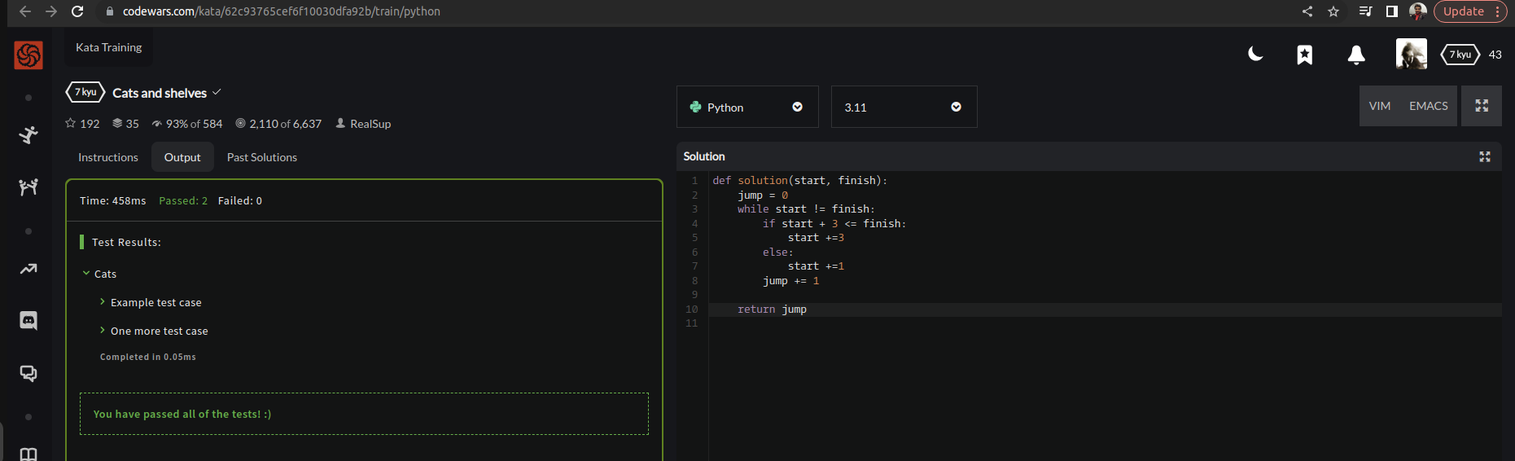

EXPLANATION:
This Python function consists of two non-negative integers start and finish. Initialize a variable jump to 0 to keep track of the number of jumps taken. While start is not equal to finish. Check if start + 3 is less than or equal to finish. If so far it’s true, jump by 3 by adding 3 to start. And If jumping by 3 would go beyond the finish point, jump by 1 by adding 1 to start. Increment the jump counter. Return the jump counter.

